Looking for an opportunity of a lifetime?

Interested in taking that next step up in your professional career?
Looking for ways to enhance your professional life and path to professional success?

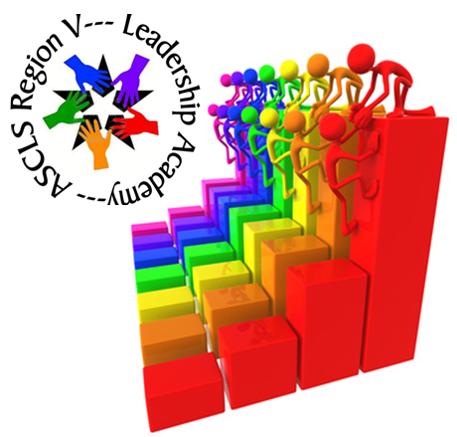

Want to enhance your leadership skills?

Want to expand your network of professional friends?

Leadership Academy
might be just the opportunity you've been looking for!
Visit the Leadership Academy website to learn more about this amazing opportunity.
The website contains information on the academy curriculum, time involvement, accountabilities, individuals to contact if you have questions, and complete information on the application/selection process.
We are accepting applications now!
We'd love to have you in our next class!

Application DEADLINE: June 1, 2018
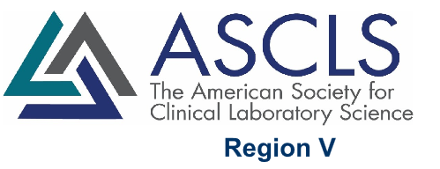
www.regionvascls.online/leadership-academy.html

